Alcohol Screening Questionnaire

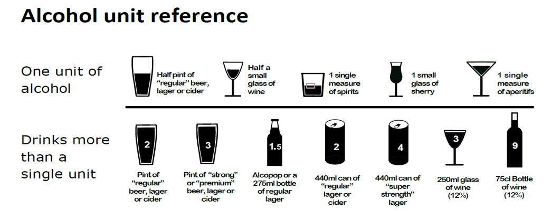
Questions | Scoring system |  |  |  |  | Your score
 | 0 | 1 | 2 | 3 | 4
How often do you have a drink that contains alcohol? | Never | Monthly or less | 2-4 times per month | 2-3 times per week | 4+ times per week
How many alcoholic drinks do you have on a typical day when you are drinking? | 1-2 | 3-4 | 5-6 | 7-9 | 10+
How often do you have 6 or more standard drinks on one occasion? | Never | Less than monthly | Monthly | Weekly | Daily or almost daily

Scoring
Score: ……………….
A total of 5+ indicates increasing or higher risk drinking. If you have a score of 5+ please complete the remaining questions below.

Questions | Scoring system |  |  |  |  | Your score
 | 0 | 1 | 2 | 3 | 4
How often during the last year have you found that you were not able to stop drinking once you had started? | Never | Less than monthly | Monthly | Weekly | Daily or almost daily
How often during the last year have you failed to do what was normally expected from you because of your drinking? | Never | Less than monthly | Monthly | Weekly | Daily or almost daily
Questions | Scoring system |  |  |  |  | Your score
 | 0 | 1 | 2 | 3 | 4
How often during the last year have you needed an alcoholic drink in the morning to get yourself going after a heavy drinking session? | Never | Less than monthly | Monthly | Weekly | Daily or almost daily
How often during the last year have you had a feeling of guilt or remorse after drinking? | Never | Less than monthly | Monthly | Weekly | Daily or almost daily
How often during the last year have you been unable to remember what happened the night before because you had been drinking? | Never | Less than monthly | Monthly | Weekly | Daily or almost daily
Have you or somebody else been injured as a result of your drinking? | No |  | Yes, but not in the last year |  | Yes, during the last year
Has a relative or friend, doctor or other health worker been concerned about your drinking or suggested that you cut down? | No |  | Yes, but not in the last year |  | Yes, during the last year

Please add up your scores from the above tables and write the total below:
Total…………………………..

If you would like help and advice on how to reduce your alcohol intake, please contact https://www.drinkaware.co.uk/ or ask at reception.

